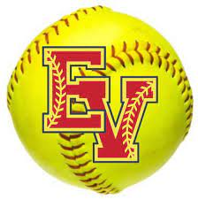East View High School Patriot Softball

**Sponsorship and Donation Opportunities!**

The East View High School Softball Team will begin their 2025 season very soon and are looking forward to building on the success of last year. To take the next step to higher levels of success, we will need suppport and assistance from our community. To successfully achieve our goals, the EVHS Softball Booster Club is asking for your financial support either by your tax deductable donations and/or Sponsorship to help cover the costs for training equipment, travel, and a variety of other needs throughout the season. With your help we can achieve great things!

We thank you for your support and in an effort show our gratitue the team will recognize your business in various ways throughout the 2025 season.

For all Sponsors we will proudly display your buisness logo on our team website [www.patriots-softball.com](http://www.patriots-softball.com) as well as give your business a “shout out” on our social media accounts. In addition, our Silver Slugger Sponsors (and above) will receive recognition at our annual Meet the Patriots (MTP) dinner fundraising event. Our Gold Glove Sponsors (and above) will receive recognition at our MTP dinner as well as by the game annoucers during the live game broadcasts of all (six) Varsity Home games by SHN Sports on their YouTube Channel. Our premier Diamond Sponsors, will recieve priority recognition at our MTP dinner and during SHN Sports live game broadcasts for every Varsity game (both home and away; 12 games in total)! As always, all Sponsors will receive a traditional Sponsor fence sign that will hang on the perimeter of Patriot Park to be seen by everyone that visits our facility.

Donations of any value are always welcome but the Sponsorship packages will help you to maximize your investment in our program with the right fit for your business. All Sponsorship levels are listed in detail on the next page. You can rest assured that every dollar donated is directly invested into our softball program for the benefit of the players and this sport that they love.

Sponsorship Forms and Payments are **due Monday, February 10th,** **2025** in order for signage to be finalized and printed prior to opening day. Sponsors are welcome to join at any time during the season and will still be eligible for announcer recognition on SHN Sports live broadcasts even after the print deadline.

If you have questions, please email us at [evhspatriotssb@gmail.com](mailto:evhspatriotssb@gmail.com) and/or take a look at our website [www.patriots-softball.com/sponsor](http://www.patriots-softball.com/sponsor)

Thank you for your continued support and involvement in our community. We look forward to welcoming your business to our East View Patriot Softball Family. We hope to see you out enjoying the games!

-East View High School Softball Booster Club

East View Patriot Softball/Head Coach: Kari Wright

East View High School Patriot Softball

Sponorship Order Form for 2024/2025

***\*\*\*Previous sponsors receive a 15% discount on orders as a thank you for their continued support.\*\*\****

**SPONSORSHIP PACKAGES:**

**Please mark your package choice.**

**Diamond Sponsor Gold Glove Sponsor Sliver Slugger Sponsor Patriot Sponsor**

|  |  |  |  |
| --- | --- | --- | --- |
| * **$750**   **Includes:**  **Gold Glove Package**  **PLUS:**   * Priority recognition by MC at Meet The Patriots dinner event * Recognition by announcer on all (12) SHN Sports live broadcasts of EVHS Softball games (both home and away) | * **$600**   **Includes:**  **Silver Slugger Package**  **PLUS:**   * Recognition by MC at Meet The Patriots dinner event * Recognition by game announcer during SHN Sports live broadcast for all (6) Varsity Home games | * **$450**   **Includes:**  **Patriot package**  **PLUS:**   * 2 complimentary tickets to Meet The Patriots dinner * Recognition by MC at Meet The Patriots dinner event | * **$300**   **Includes:**   * Advertising Fence Sign @ Patriot Park * Recognition as Sponsor on Team Website (www.patriots-softball.com) |

>> For custom packages, send email to evhspatriotssb@gmail.com <<

SPONSOR:_________________________________________________________________________________________________

CONTACT NAME:___________________________________________CONTACT PHONE_________________________________

ADDRESS:_______________________________________CITY:________________________STATE:___ ________ZIP:_________

WEBSITE:__________________________________________________________________________________________________

EMAIL:______________________________________________

Please make checks payable to EVHS Softball Boosters or submit your payment online via our

PayPal account at [www.patriots-softball.com/sponsor](http://www.patriots-softball.com/sponsor) (click Make a Donation button)

We can also arrange for order forms and checks to be picked up by one of our EVHS Softball Booster Officers. Please email for details.

Order total:_______________ Discount:____________Amount Paid:___________ Check #__________Paid Online:___Y____N__

Player Contact:_______________________________________________Date:________________________________________

For questions or more information, please visit our website www.patriots-softball.com or send email to evhspatriotssb@gmail.com

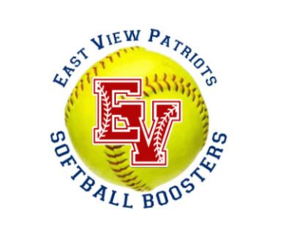 Sponsorship Forms and Payments are **due Monday, February 10th,** **2025** in order for signage to be finalized and printed prior to opening day.

Thank you for your support!

**2025 EVHS Softball Program**